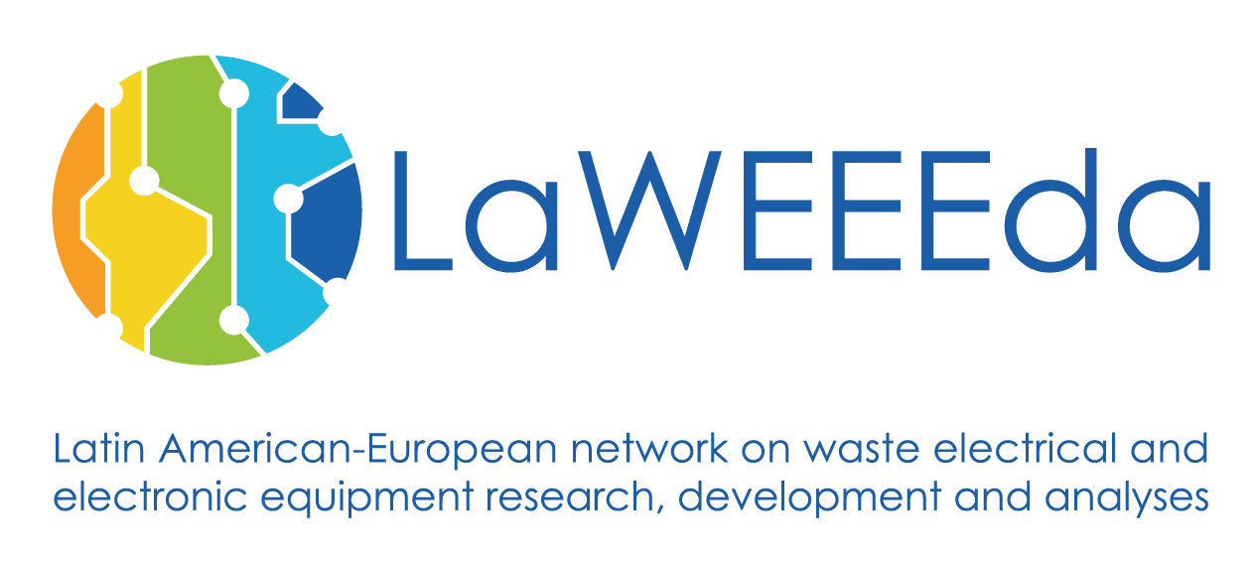

**Partner Meeting at ULSA, León, Nicaragua**

**3rd- 7th July 2017**

**PARTNER MEETING**

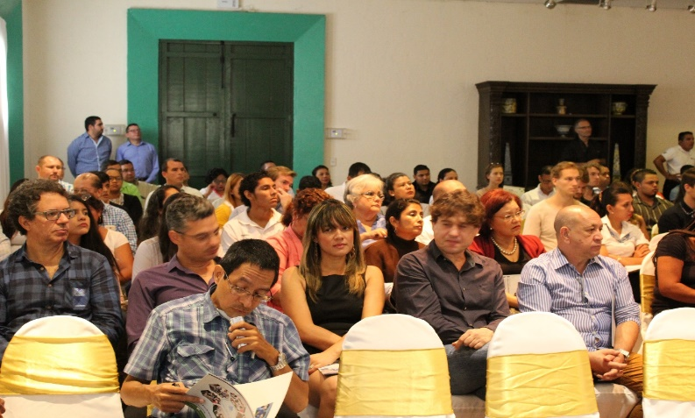

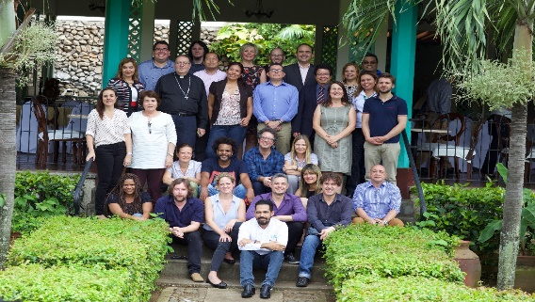

Figure 2: The LaWEEEda Team

disposal waste in Leon

Figure 1: Kick-off meeting in León, Nicaragua

# Overview

There is no payment for the 80 persons who recover material at the landfill site. Thus, they work on their own risk without any safety considerations in the search of materials they can sell in order to make a living. At one point, there were plans to excavate and create a land fill area to improve the conditions and to prevent hazardous materials to leak into the soil and groundwater. However, due to lack of funding the project never got further than digging the hole.

The second partner meeting in Leon, Nicaragua comprised an official project opening for Nicaraguan partners, site visits to the Leon landfill site and Hanter Metals (Managua), the development of equipment lists for the LaWEEEda training centres and workshops on teaching approaches.

**Visit at Leon landfill site**

The only legal waste disposal site for the 210,000 inhabitants in Leon has bad sanitary conditions, which exposes workers to many potential health risks reducing their life expectancy to between 50 and 60 years of age. There are also several illegal dump sites.

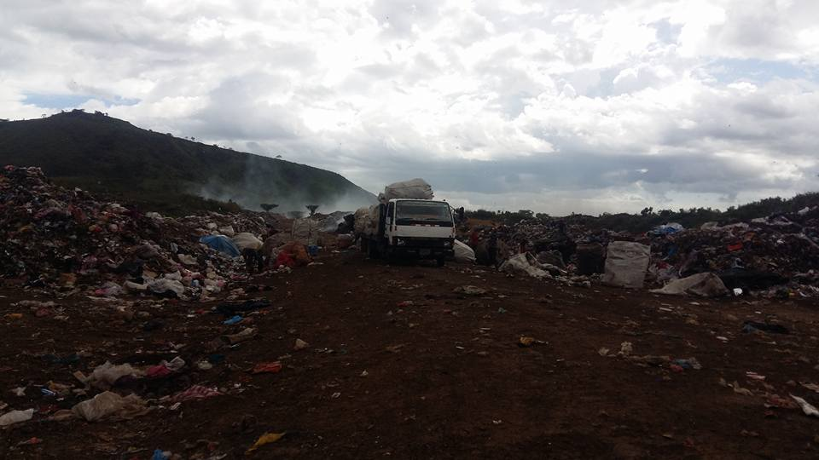

Figure 3: Disposal site of the city of Leon

# Quality indicators

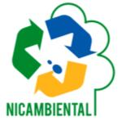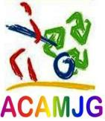

**27.6 Co. Ltd**



# Site visit To Hanter metals

Three indicators were classified as the common basis for understanding of “quality indicators”. The first one is monitoring which can be taken care of by the reports. The second one, the degree of collaboration between Universities and the public sector, in particular companies. The third one is the teaching material, like course contents. Of course, one cannot forget the social impact that goes beyond the cooperation with companies.

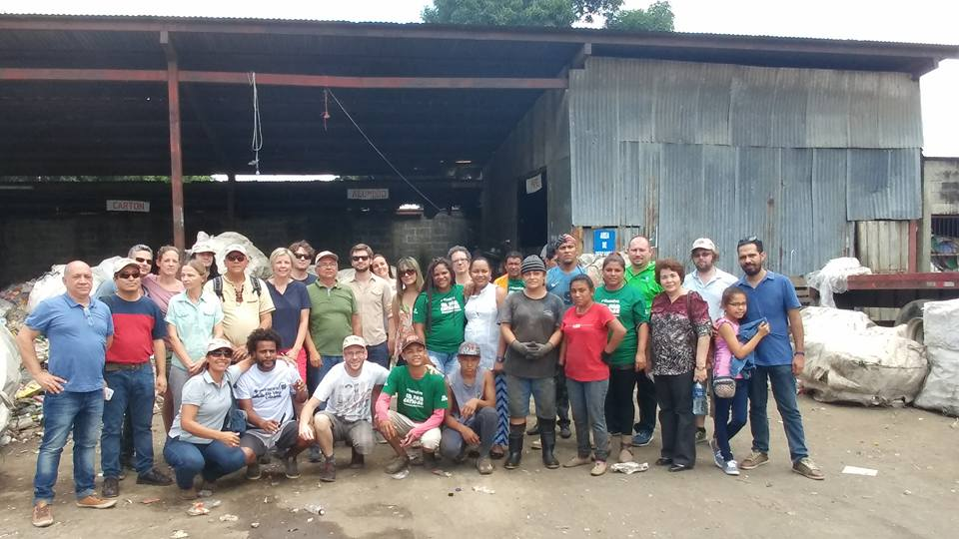

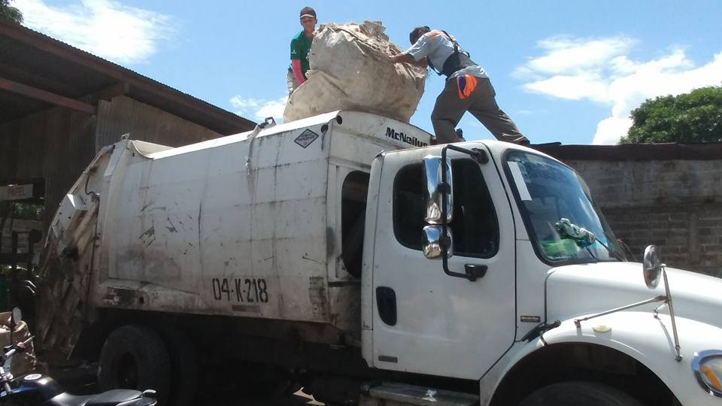

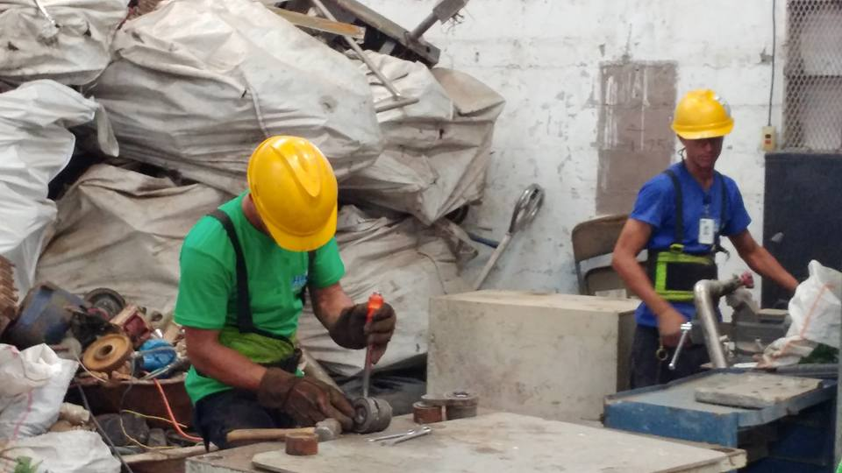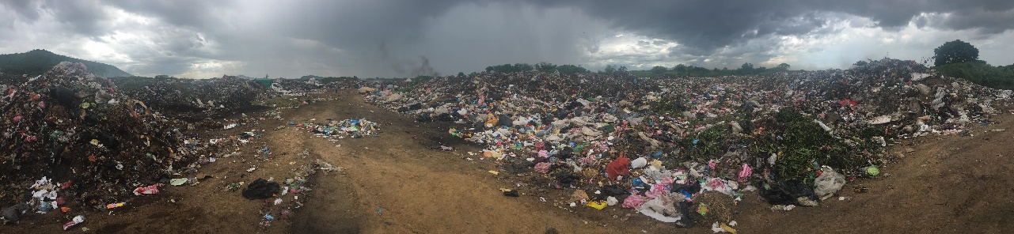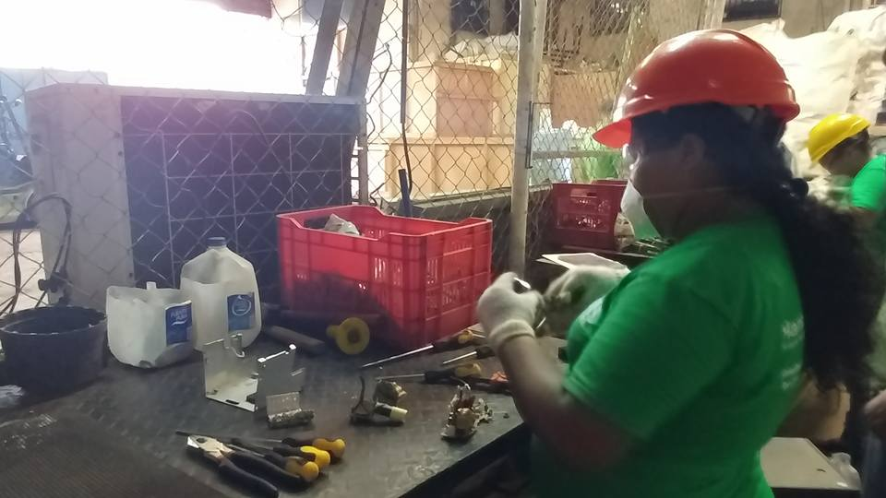

Figure 8: landfill in Leon, Nicaragua

Figure 7: Disassembly process at Hanter Metals

Figure 6: Dismantling at Hanter Metals in Managua

Figure 5: Delivering recyclable materials at 3RVargas

Figure 4: Visit to Recyclers “MIPYME”, Managua