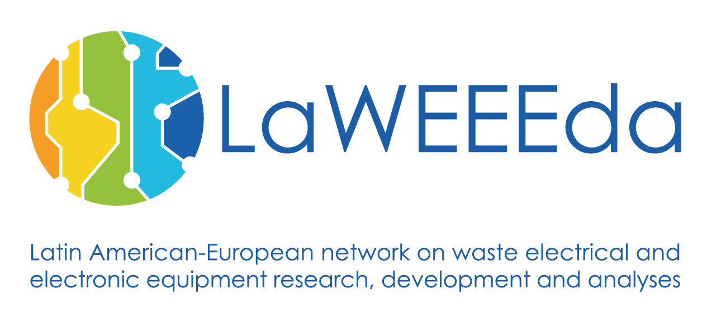

**Consortium Meeting & Development Workshop 1 in Vienna, Austria**

**14th- 17th December 2017**

**CONSORTIUM MEETING AND DEVELOPMENT WORKSHOP**

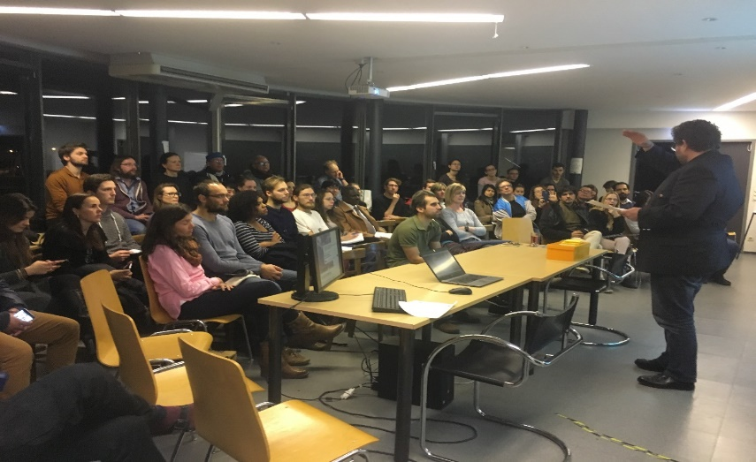

Figure 1: CDR event

# overview

The 3rd partner meeting took place in Vienna at BOKU University. This was used as an opportunity to disseminate the project activities at BOKU University and to share knowledge with the Center for Development Research at BOKU. Further a site visit to DRZ took place and a session was dedicated to the view of business partners in the project.

Figure 2: flyer of CDR meeting in Vienna

A workshop was dedicated to discuss the role and tasks of business partners in the project. The results can be summarized as follows: It is important to compile information on WEEE in countries like Nicaragua, where limited insight to this sector is available. Today, only the poor do recycling to make some money; they realized that this is different in Europe. One step for a change in Nicaragua can be a campaign “*Donate your WEEE and save our precious wood*” in co-operation with private companies. It is seen as a social project: new entrepreneurship with WEEE in Managua shall promote alternatives for youth and train them to improve technical skills and generate income.

The Center for Development Research at BOKU University Vienna is a platform of researchers from various Institutes at BOKU University, sharing an interest and engagement in Global Development. The platform holds regular meetings for the exchange of experience and runs projects in cooperation with partners in Africa, Latin America and Asia. Partners from CRD attended the event on e-waste management in Latin America on Dec. 14th 2017.

# business partner view

# CDR Event

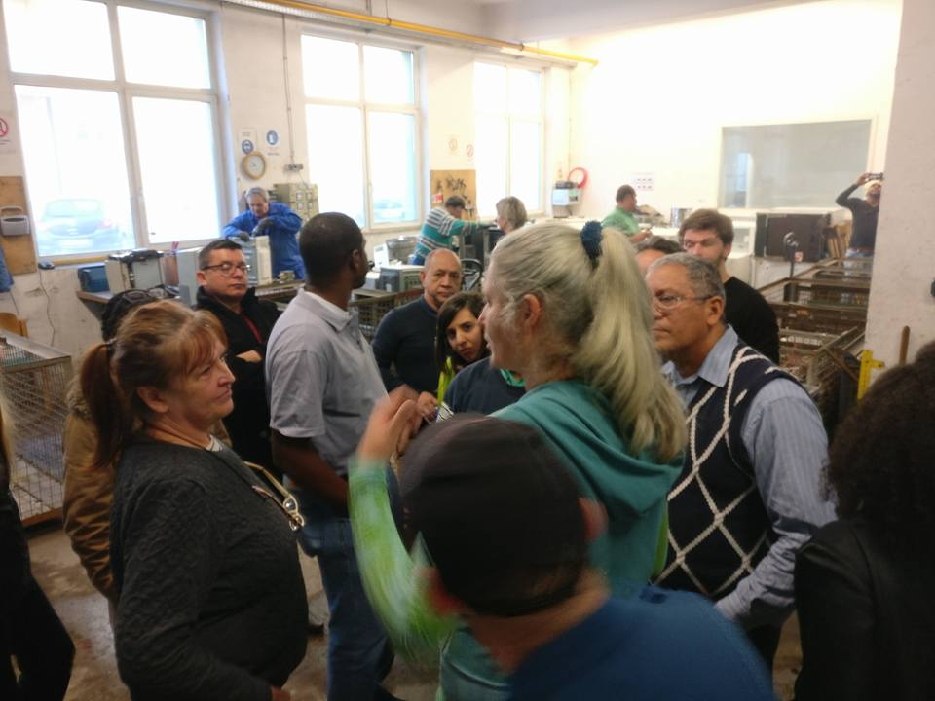

Visit of the Demontage und Recycling Zentrum (DRZ); The partners had the possibility to see dismantling activities and the related equipment in a real life business situation.

# SITE visit to DRZ

Figure 3: Site visit DRZ

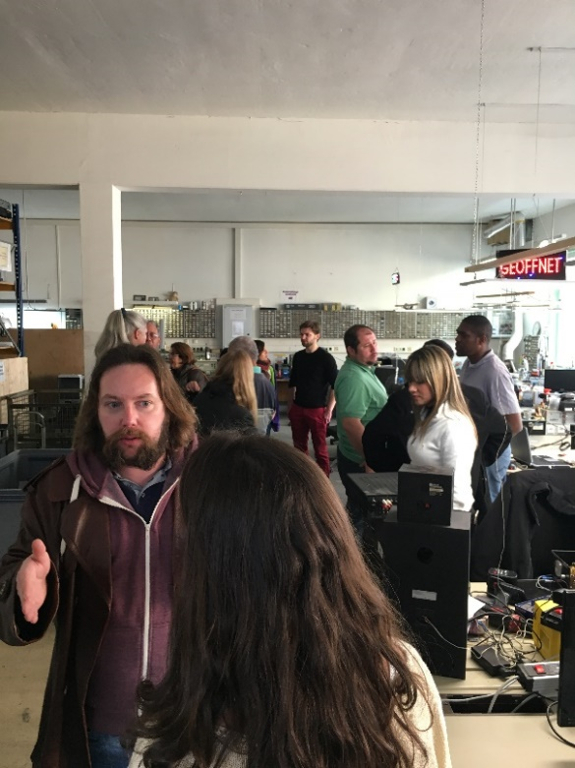

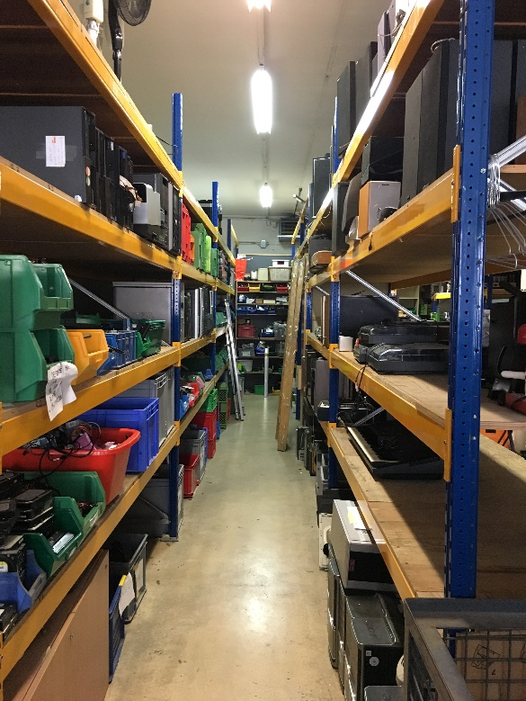

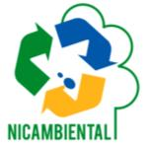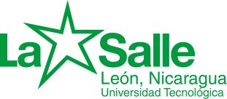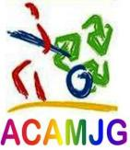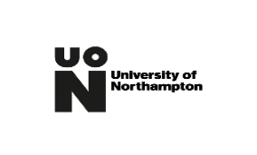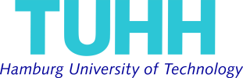

**Hanter metals**

Figure 5: Site visit DRZ

Figure 4: Site visit DRZ

