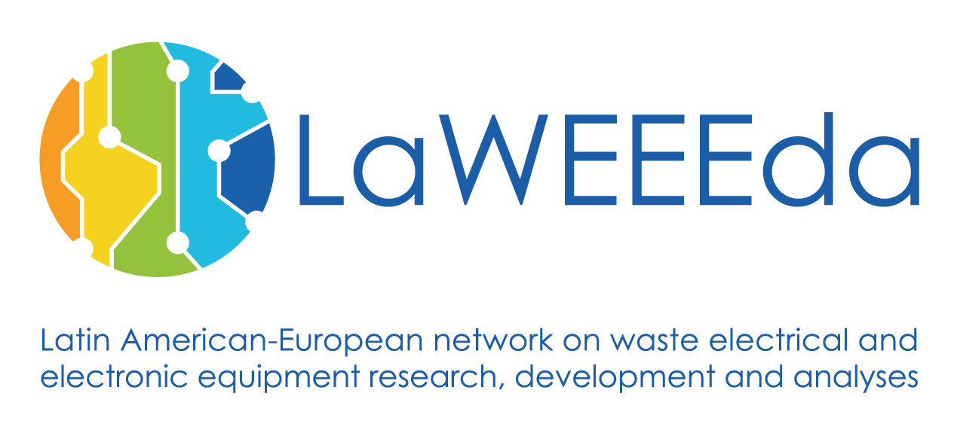

**Consortium Meeting & Development Workshop 2 & 3 in Hamburg, Germany**

**2nd- 6th July 2018**

**CONSORTIUM MEETING AND DEVELOPMENT WORKSHOP 2 & 3**

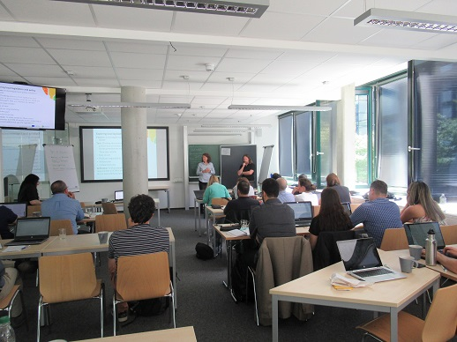

# DAAD meeting

For this meeting, Dr. Michael Eschweiler as a representative of DAAD was invited to exchange experience on present and future cooperation programs in Latin America. There is a number of programs on technical cooperation and exchange of staff and students, that might be relevant for future cooperation of European (mainly German) and Latin American partners. Among others, partners in Nicaragua see the potential to develop a project related to the value chain in recycling.

**Policy and legislation for e-waste:**

In Brazil a national solid waste policy was introduced 8 years ago. Based on this, sectoral agreement for some types of waste have been established but not for WEEE. The distinctive management of waste on the level of States (legislative autonomy) makes the environmental licensing process harder, contributing to an increase of informal sector. A high demand today meets unavailability of formal recycling infrastructure.

Nicaragua struggles with the absent of a specific legislation and regulation agencies; a guideline is necessary in order to fill this gap and implement the regulations properly. Currently there is a law describing which materials are considered as hazardous, but it has not been implemented so far. Furthermore, there is no specific legislation, which regulates WEEE management.

# DEvelopment of the training Materials

As a next step to develop the training centres, roadmaps will be established, in a later phase to be further developed into business plans.

- Each university should have similar roadmaps and business model methodology; roadmaps must be strategic brochures with 6 phases (goals, innovation, stages and market, costs analysis, timeline, personnel) that each partner entity should meet;

- Discussion about the timeframe: short (2 years), medium (5 years) and long term (10 years); this timeline must be specified in the roadmaps.

In a next step, the following equipment will be purchased: e-waste dismantling tools, Personal Protective Equipment, laboratory consumables, discussion about the purchase of other equipment, such as XRF analyser or shredder.

# DEvelopment of the training centres

The forth partner meeting took place at TU Hamburg. Main topics of this meeting was an exchange of experience with DAAD, next steps for the development of the training centres, content of the training materials and site visits.

# overview

Figure 1: Development workshop

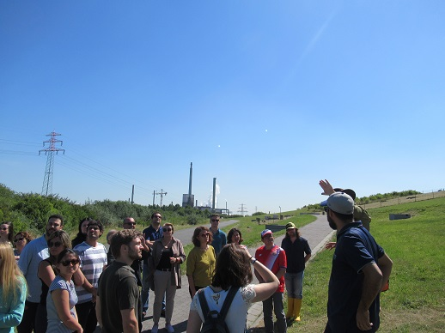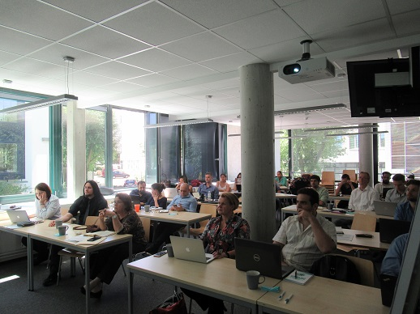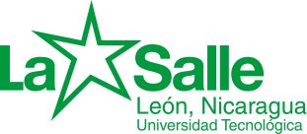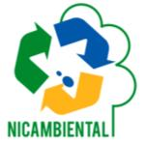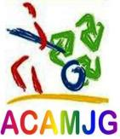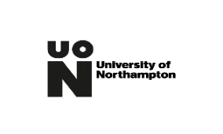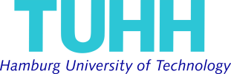

**Hanter metals**

**Ideas and expectations:**

- Universities seek research cooperation with business partners with a focus on technical issues; Universities want to provide training courses for students (e.g. internships) in order to introduce them in the companies workforce (LaWEEEda staff should be the first option);

- Business partners should share their knowledge with universities (not only in technical terms but also in the market context, new developments, etc.); suggests also the inclusion of non-academic public (e.g. informal sector);

- Support from business partners in terms of materials, tools and knowledge for trainings.

Business partner want to establish an internship framework for future cooperation;

- Regular and mutual exchange of information amongst partners since the context of each country is different.

# ROles of busiNess Partners

Figure 2: Visit of the Energieberg

Figure 3: LAWEEda presentation

